Digital Logic Design (DLD)
Mid Question Answer
Lecture – 1
1. What is Digital Logic Design?
Ans: The digital logic design is a system in electrical and computer engineering that uses simple numerical values to produce input and output operations. Assist in developing cell phones, computers, and related personal electronic devices.
2. How type of Numerical Representations?
Two ways of representing the numerical value of quantities: i. Analog and
ii. Digital
i. Analog Representations:
In analog representation a quantity is represented by a continuously variable, proportional indicator.
Analog = Continuous

ii. Digital Representations:
In digital representation the quantities are represented not by continuously variable indicators but by symbols called digits. As an example, consider the digital clock.
Digital = Discrete (step by step)

3. Example 1: Which of the following involve analog quantities and which involve digital quantities?
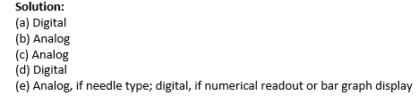
(a) Ten-position switch
(b) Current flowing from an electrical switch
(c) Temperature of a room
(d) Sand grains on the beach
(e) Automobile fuel gauge

4. Define Digital and Analog System.
Digital System: A digital system is a combination of devices designed to manipulate logical information or physical quantities that are represented in digital form

Analog System: An analog system contains devices that manipulate physical quantities that are represented in analog form.

5. Advantages of Digital Techniques.
1. Digital systems are generally easier to design.
2. Information storage is easy.
3. Accuracy and precision are easier to maintain throughout the system.
4. Operation can be programmed.
5. Digital circuits are less affected by noise.
6. More digital circuitry can be fabricated on IC chips.

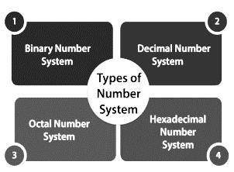
6. Type of Number System. Page (7-10)
i. Binary Number: Base 2. Carries only two digits, like that 0 or 1.
ii. Decimal Number: Base 10. Contain Ten digits, 0 to 9.
iii. Octal Number: Base 8. Contain Eight digit, 0 to 7.
iv. Hexadecimal Number: Base 16. Contain total 16 symbols like 0 to 15 (0,1,2,3,4,5,6,7,8,9, A, B, C, D, F)

7. Number Base Conversion.
Ans: Page 11-19
Lecture – 2
8. What is Binary Codes?
Ans: In the coding, when numbers, letters or words are represented by a specific group of symbols, it is said that the number, letter or word is being encoded.
9. Advantages of Binary code.
1. Binary codes are suitable for the computer applications.
2. suitable for the digital communications.
3. the analysis and designing of digital circuits much easier.
4. Since only 0 & 1 are being used, implementation becomes easy.
10. Classification of Binary Codes
• Binary Coded Decimal (BCD) Code
• Gray Code
• Excess-3 Code
• Alphanumeric Codes
• Error Detecting Codes
• Error Correcting Codes
11. Explain and Conversion BCD Code.
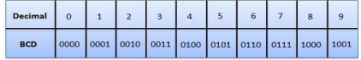
In this code each decimal digit is represented by a 4-bit binary number. BCD is a way to express each of the decimal digits with a binary code. BCD code only first ten (0000 to 1001) of these are used.

12. Advantages and Disadvantages of BCD Code.
Advantage:
• It is very similar to decimal system.
• We need to remember binary equivalent of decimal numbers 0 to 9 only.
Disadvantages:
• The addition and subtraction of BCD have different rules
• The BCD arithmetic is little more complicated.
• BCD needs a greater number of bits than binary to represent the decimal number.

13. Define Gray Code.
Ans: The Gray Code is a sequence of binary number systems, which is also known as Reflected Binary Code (RBC).
Conversion -> i. Binary to Gray code and ii. Gray to Binary code.
Ans: i. page (3-4) ii. Page (4-5)

14. Explain Gray code characteristics.
• In Gray code, two consecutive values are differed by one bit of binary digits
• Binary number is converted to Gray code to reduce the switching operation.

15. Conversion Binary to Exces-3 code.
Ans: page (7-8)

- Methods for Finding Excess-3 code of Binary Number.
Method 01:
• We find the decimal number of the given binary number.
• Then we add 3 in each digit of the decimal number.
• Now, we find the binary code of each digit of the newly generated decimal number.
Method 02:
- We can also add 0011 in each 4-bit BCD code of the decimal number for getting excess-3 code.

16. Self-Complementary Property.
Ans: Page (09)

• A self-complementary binary code is a code which is always complimented in itself. By replacing the bit 0 to 1 and 1 to 0 of a number, we find the 1's complement of the number.

• If we perform the 1's complement of excess-3 of a decimal number, it will be equal to the excess-3 code of the 9's complement of that decimal number.

17. Difference Between Unicode and ASCII
Unicode Coding Scheme | ASCII Coding Scheme
It uses variable bit encoding according to the requirement. For example, UTF- 8, UTF-16, UTF-32 | It uses 7-bit encoding. As of now, the extended form uses 8-bit encoding.
It is a standard form | It is not a standard all over the world.
People use this scheme all over the world | It has only limited characters hence, it cannot be used all over the world.
It has more than 128,000 characters. | In contrast, it has only 256 characters

Lecture – 03
18. Define De Morgan’s Theorems.
Ans: There are two basic theorems of great importance in Boolean Algebra, which are De Morgan’s First Law and De Morgan’s Second Law. These are also called De Morgan’s Theorems.

i. De Morgan’s First Law: (P.Q)' = (P)' + (Q)'
ii. De Morgan’s Second Law: (P + Q)' = (P)'. (Q)'
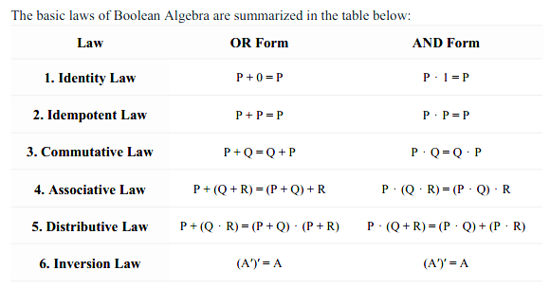
19. Applications of Boolean Algebra
- Digital Logic Design
- Algorithm Design
- Telecommunications
- Artificial Intelligence (AI)
- Electrical Engineering

20. Math page (6-10)

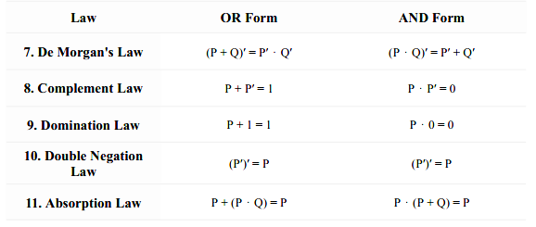

Lecture – 04
21. Advantage and Disadvantages of K-Map.
Advantages:
- Makes Logic Simpler
- Minimizes Logic Gates
- Reduce Errors
- Time-Saving
- No need for Boolean Laws
Disadvantages:
- Limited to Fewer Variables
- Not suitable for all functions
- Space Limitations
- Requires Careful Grouping

22. Math page (1-04).

